Ideation Phase
Brainstorm & Idea Prioritization Template

Date | 20 February 2026
Team ID | LTVIP2026TMIDS41306
Project Name | Plugging into the Future: An Exploration of Electricity Consumption Patterns Using Tableau
Maximum Marks | 4 Marks

Brainstorm & Idea Prioritization
Brainstorming helps the team generate creative ideas to analyze and visualize electricity consumption data effectively. Various solutions such as interactive dashboards, peak demand analysis, and trend identification using Tableau are explored. Idea prioritization ensures selection of the most feasible and impactful solutions to support efficient energy planning and data-driven decision-making.
Reference: https://www.mural.co/templates/brainstorm-and-idea-prioritization
Step-1: Team Gathering, Collaboration and Select the Problem Statement
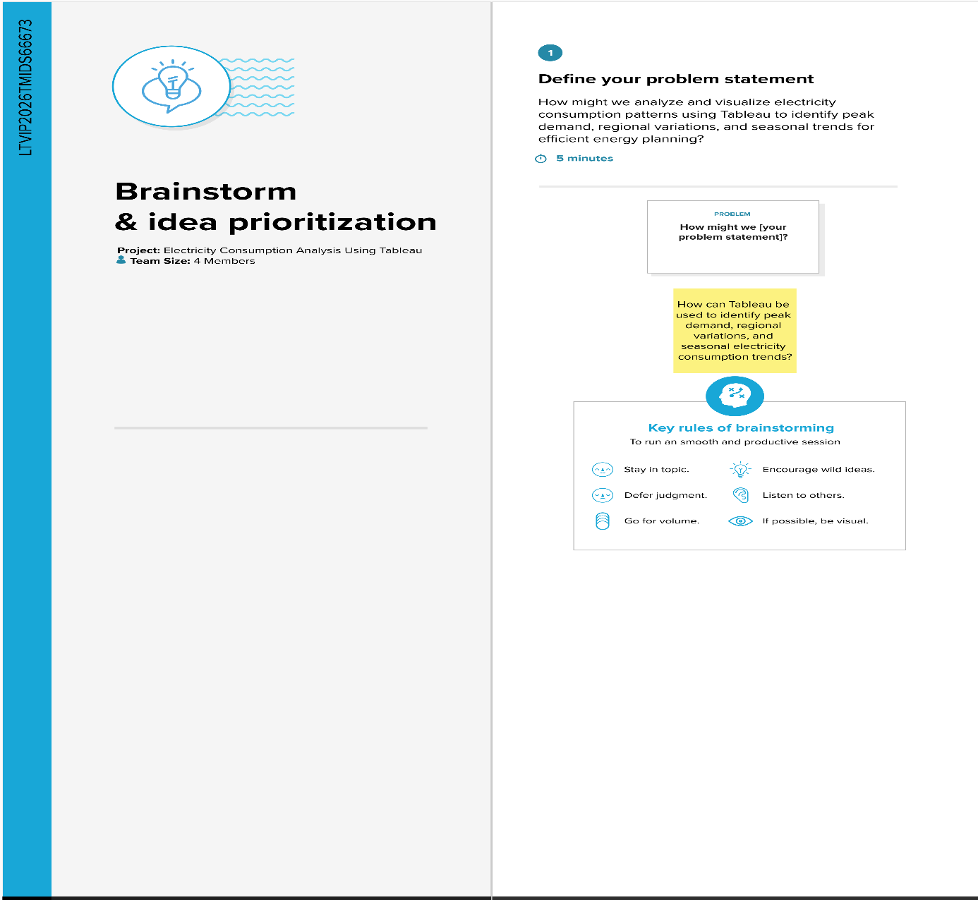

Step-2: Brainstorm, Idea Listing and Grouping
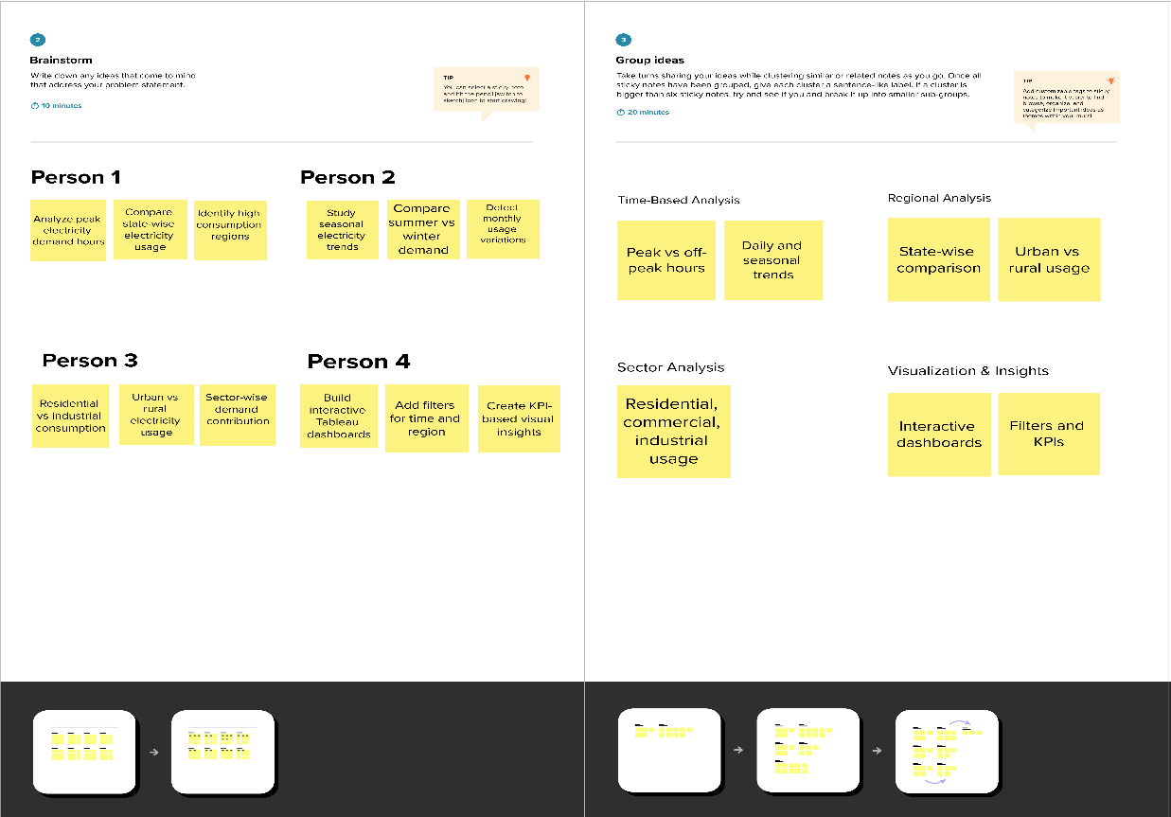

Step-3: Idea Prioritization
